Due Diligence Automation System
User Manual

Version 1.0
1-August-2017

Developed by:
Clarity Information Technologies Pvt. Ltd.
Bangalore.
Tele: 080 - 2529 1698
Email: mail@claritytechnologies.com

Table of Contents
Introduction 3
Login 4
Forgot Password 4
Change Password 4
Due Diligence Search 5
Compliance Form 8
General Info 9
Institute 10
Mandatory Sites 12
Additional Sites 15
Findings 16
Configurations 19
Site Sources 19
Default Sites 20
Country Specific Site Sources 21
Sponsor Specific Site Sources 21
Data Structures 22
Compliance Form Data Structure 22

Introduction

DDAS is a Web Application and can be accessed through: http: …. on your web browser.
The main goal of the DDAS application is to aid the user to collate Investigator and Institute related Complaince Issues into Investigator Compliance Search Forms (ICSF).
The application collects Investigator Compliance related data from various pubic sources. The application downloads this every 24 hours and converts it into data repositories.
The application user inputs details such as Project Number, Name of Institute, Country, List of Investigators and their Role, Prinicpal or Sub. The application scans through the latest version of the data repositories for suitable match of Invesigator Name and presents the results to the user for recording observations.
The data is extracted from the following web sites –
- FDA Debarment List
- Clinical Investigator Inspection List (CLIL)(CDER)
- FDA Warning Letters and Responses
- Notice of Opportunity for Hearing (NOOH) – Proposal to Debar
- Adequate Assurances List for Clinical Investigators
- Clinical Investigators – Disqualification Proceedings (FDA Disqualified/Restricted)
- Clinical Investigator Inspection List (CBER)
- PHS Administrative Actions Listing
- HHS/OIG/ EXCLUSIONS DATABASE SEARCH/ FRAUD
- HHS/OIG Corporate Integrity Agreements/Watch List
- SAM/SYSTEM FOR AWARD MANAGEMENT
- LIST OF SPECIALLY DESIGNATED NATIONALS

Login

Navigate to DDAS via http:// in your internet browser. Username and Password are mandatory fields for logging in.

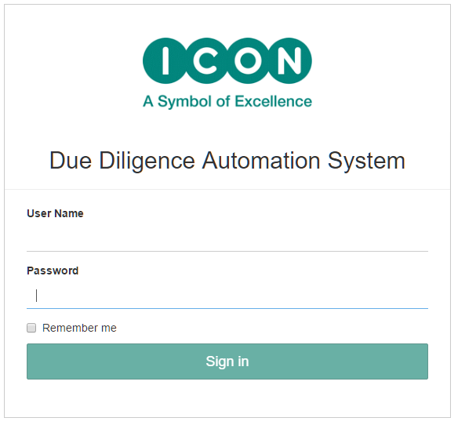

Forgot Password

Not implemented:
Forgotten passwords can be recovered using the ‘Forgot Password’ link on the login page.
Enter your username and e-mail address and click on ‘Re-Generate Password’ as shown below.
An e-mail will be sent to the user’s e-mail address with the re-generated password.
In the event that the ‘Re-generate password’ link is not working please e-mail the DDAS Administrator mailbox: xxxxxxxx for assistance.
The re-generated password can be changed using the ‘Change Password’ link (see next section).

Change Password
The Change password link is accessible via the user menu on the top left-hand side of the screen.

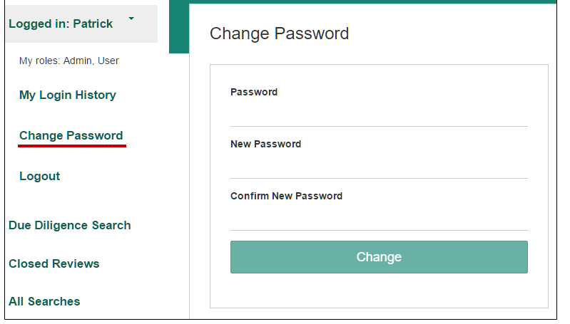

Click ‘Change Password’ to display this screen:

Complete all fields and click update to change the password.

Due Diligence Search

The Due Diligence Search page will be visible to the user immediately after login.

The user can carry out the following actions:

- Create a Compliance Form and Carry out Manual Search
- Batch Upload an excel file containing multiple data for Compliance Forms
- Download a Compliance Form Template
- Legend
- Open a Compliance Form for Review

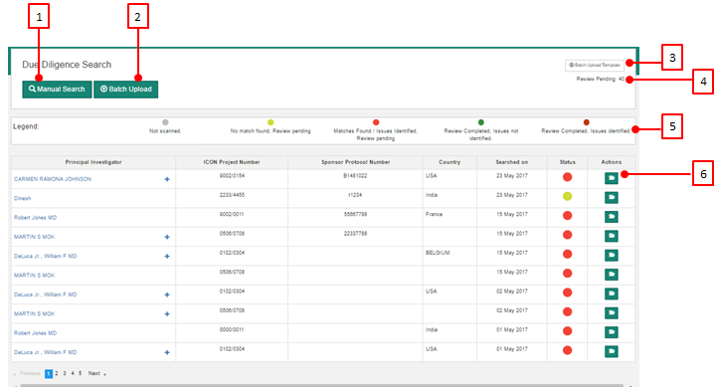

1. Manual Search

In this section, compliance form details are to be entered manually. Follow the below steps to create a compliance search form manually
  - Fill up the details in ‘General Info’ tab
  - Provide the investigator details in the ‘Investigators’ tab
  - Name entered in the column ‘Name to Search’ will be taken up to search in the database
  - Name provided under the column ‘Name (for display)’ will be displayed in the ICSF
  - The application considers the first Investigator to be a ‘Principal Investigator’
  - Investigator name to be searched must have at least two components (first name, last name / last name, middle name / first name, middle name… etc)
  - ‘Investigator Id’ and ‘Member Id’ will not be displayed in the ICSF. This information will only be available in the output file
  - After filling up all fields, save the compliance form to carry out the search. The search is auomatically carried out when the Compliance Form is saved. Repeat saving does not re-execute the search operation for the aleeady searched Investigators, however search operation for the additionl investigators will be executed.
  - After the search, Status column indicates whether full/partial/no matches found for respective investigators
  - Details of the search results can be viewed from ‘Actions’ column. Opening the investigator search results will display the ‘Investigator Search Summary’ screen
  - Actions column also provides the functionality to move an investigator up/down. Any investigator in the first row is considered as Principal Investigator.
  - Any investigator can be removed from the search

2. Batch Upload

Any number of investigator can be searched by uploading an excel template(downloading this template is covered in the next step)

- Fill up the details as per the excel file and upload into the application using ‘Batch Upload’ option
- Application validates the data in the file and carries to search operation in case of no errors, otherwise application will provide error details and the line number where error has occurred. User should update the file with valid data and upload again
- Application will display all the investigators uploaded from the excel template along with status of the investigators
- User can view/edit the search results from the actions column

3. Batch Upload Template

Download the template which is the only format the application accepts to perform searches on the given investigators. Template will be downloaded as ‘DDAS_Upload_Template.xlsx’

4. Legend

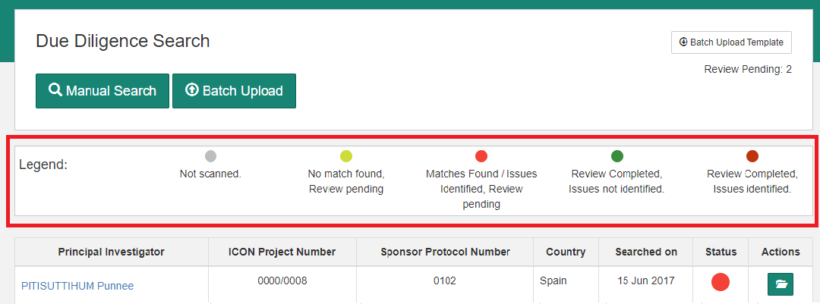

Legend indicates the status of a compliance form/investigator. Application updates the status of a compliance form/investigator when a compliance form is created/updated.

Legend contains following statuses
- Not scanned – could not carry out the search
- No match found, Review pending – Completed search. No match found for any of the given investigators. Application marks all the sites for which data is extracted, as ‘Review Completed’ when there are no matches found. Additional sites are also marked as ‘Review Completed’, by default
- Matches Found / Issues Identified, Review pending –
  - Matches Found - During search if there are any matches found (full/partial) the status is updated as ‘Matches Found’ for the given investigator
  - Issues Indetified - If user identifies any of the matches found as an issue, status of the respective investigator is updated to ‘Issues Identified’
- Review Completed, Issues not identified
- Review Completed, Issues identified

5. Open Compliance Form for Edit

After the search is completed, compliance form details can be viewed or edited. Compliance form data is divided into 8 tabs, each of which are described in the next section.

Compliance Form

The information in the Compliance form is arranged in 8 tabs.

- General Info
- Institute
- Investigators
  - Investigator Search Summary
    - Findings
- Mandatory Sites
- Additional Sites
- Findings
- Searched By
- Summary
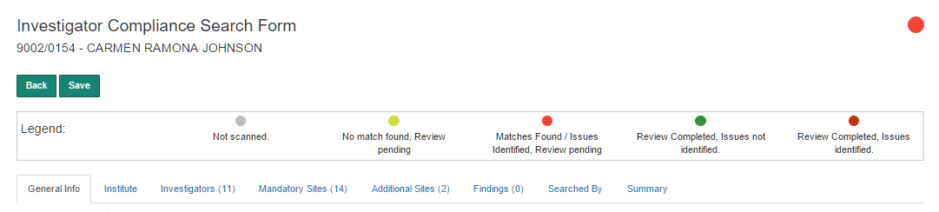

General Info

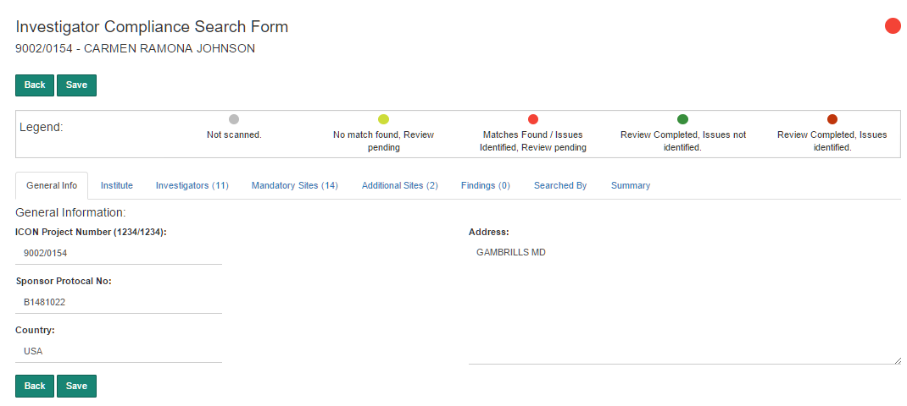

The fields are:
ICON Project Number
Format: dddd/dddd example: 1234/5678
The first 4 digits of the Project Number represent the sponsor.
Institute:
Address
Country

Institute

The Institute tab displays the Institute Name and the list of Site Sources where Search Applies to given Institute.

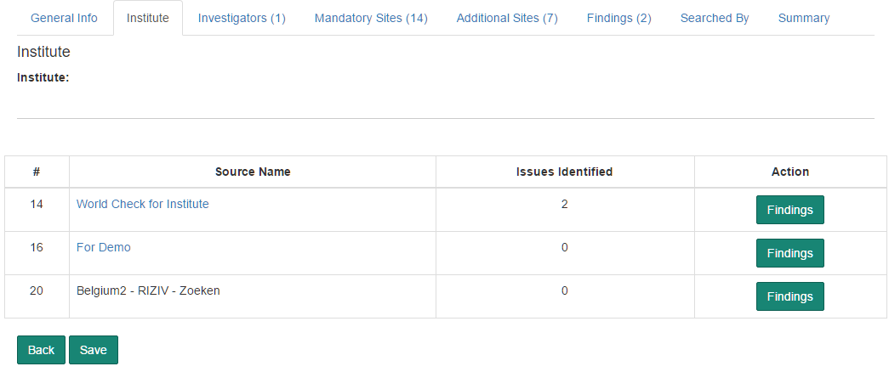

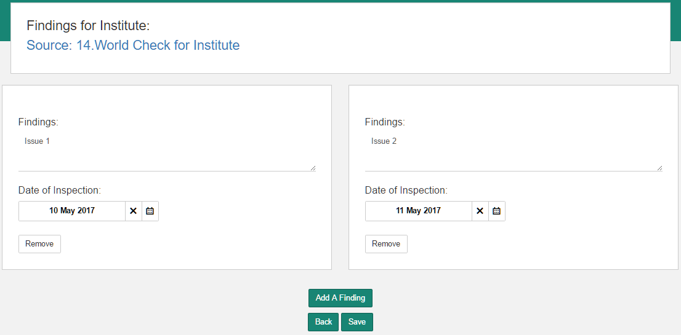

Investigators

Investigators added (with batch upload/manually using ‘Add an Investigator’ button) appear under this tab.

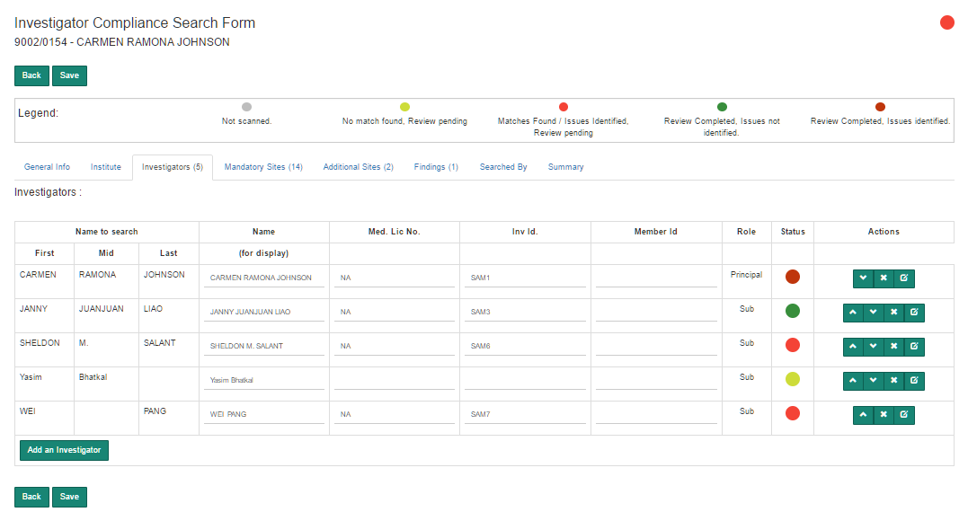

- Name entered in the column – Name (for display) , will be for display purpose and will be displayed in the ICSF
- Name entered in the columns – First, Mid and Last will be taken up to search in all the sites
- User can make any investigator a Principal Investigator/Sub Investigator by using up/down arrows. The Investigators will appear in same order in the ICSF
- User can delete an investigator
- User can add an investigator to search

Investigator Search Summary

This section displays all mandatory and additional sites (if any) along with full/partial/single component match counts after the search is completed.

Below are the actions user can perform on this screen -
- A Check box is provided to hide/show the sites along with the full/partial match counts.
- For a given investigator, when search does not return any matching records for a site(mandatory/additional), application marks the respective site as ‘Review Completed’
- User can view all sites by unchecking the ‘Hide Review Completed Sites’ option
- User can add/update/remove findings which is described in the next section

Findings

Search result for an investigator includes – full/partial/single component matches along with status and Issues Identified flags.

When a match is found, application displays record details which user can add into the ‘Findings’ section.

User can also add ‘Additional Finding’ where, unlike matching records, the observation will have to be added manually without any matching record information.

Follow below steps to add a Finding -
- Click on any of the matched record, if match is found (full/partial/single) or on ‘Review Matching Records’ button
- Select any record and click on ‘Add to Findings’
- Enter record details/any observation into the ‘observations’
- ‘Date of Inspection’ is added by the application for ‘DB’ sites. User will have to add the Date of Inspection manually in case of additional/manual sites
- ‘Is an Issue’ is checked by default, which indicates that the selected record is a positive match for the given search name. User can uncheck this option
- To complete review for a site, User has to check the ‘Review completed’ option which indicates that the matched records (if any) have been checked
- User can mark a site as ‘Review Completed’ by not identifying any issues, even when the application displays matched records. It is the user who decides whether a record can be added as an issue
- In case of no matches found – user can add ‘Additional Findings’. User can provide observations, identify it as an issue and mark the site as ‘Review Completed’

Mandatory Sites

This section displays the sites that are part of the search by default. These sites cannot be modified.

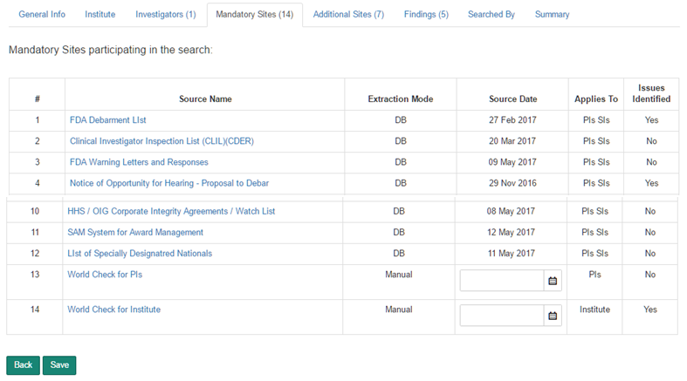

Additional Sites

As a part of the search, In addition to mandatory sites, additional sites can also be added.
Note: (Applies to Mandatory and Additional Site)
Source Date is automatically generated for sites applicable to PIs and SIs and whose extraction mode is ‘DB’ . For other sites, the Source Date is recorded by the user.

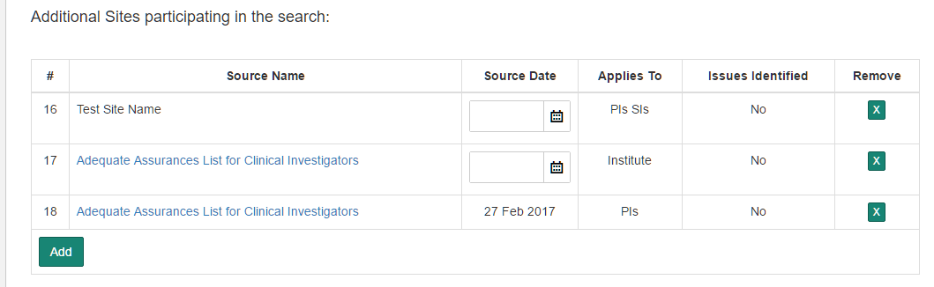

Findings

This tab displays all the findings added for each investigator and Institute findings as well (if any)

The findings are listed in the following order:
- Institute in ascending order,
- And then by Source # in ascending order,
- And then by Date of Inspection in descending order
- And then by Investigator in the same order as the record appears on the Compliance Form,
- And then by Source # in ascending order
- And then by Date of Inspection in descending order.

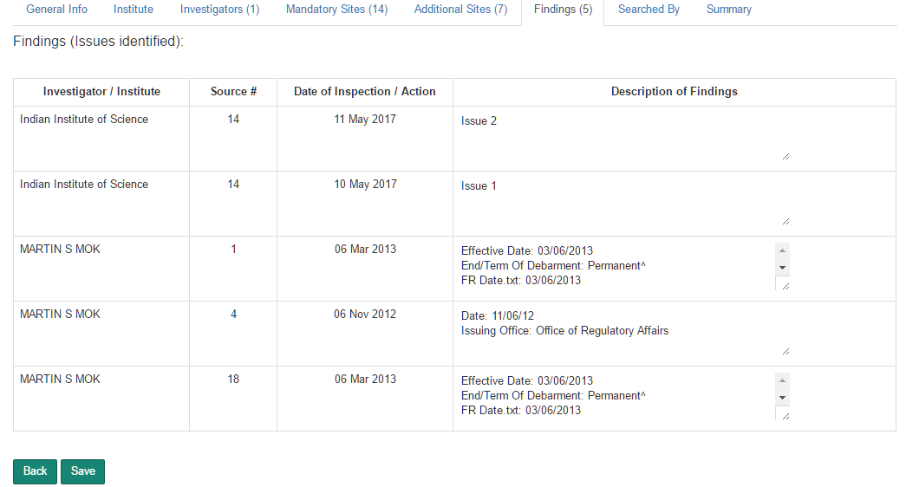

Searched By

This section displays the name of the user performing the search and the date search started on.
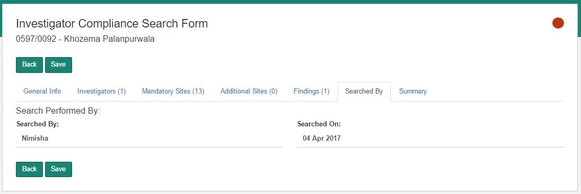

Summary

This section displays summary of the compliance form added by any user.
Following details are displayed –
- Name of the file uploaded by the user (Uploaded File can be downloaded, for reference)
- Name of investigator
- Search started on date and Review completed on for each investigator

Configurations

Site Sources

The Site Sources section displays all the sites available for use with Compliance Forms. The list contains 12 pre-defined Site Sources. The extraction mode for these sites is ‘DB’. These records cannot be removed or modified.
Additional sites can be added to the Site Source list. The extraction mode for additional sites is automatically marked as ‘Manual’
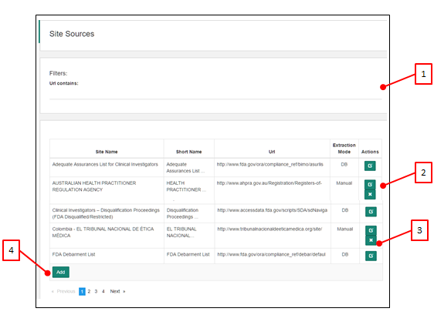
- Filters - ‘Url contains’ Filters records matching the text in the Url contains text box.
- Edit Record - Applies to Manual sites. DB Sites cannot be edited.
- Remove Record - Applies to Manual sites. DB Sites cannot be removed.
- Add a new Site Source with the following values:
  - Site Name
  - Short Name
  - URL
  - Extraction Mode: Manual

Default Sites

The application maintains a list of Default Sites. The Site Sources listed under this section are added to the compliance form when the form is created.
The fields in the Default Site are:
- Site Url: Selected from the list of Site Sources. Site Sources are managed in the Site Source section.
- Order No: Defines the order in which the Site Sources have to appear in the Compliance Form.
- Name: By default, the Site Name provided by the Site Source is applied. This can be modified.
- Search Applies To options are:
  - Principal Investigator and Sub Investigator
  - Principal Investigator
  - Institute
- Mandatory, Yes / No. Mandatory Site Sources are listed under the Mandatory section of the Compliance Form. Not Mandatory Site Sources are listed in the ‘Additional Sites to Search’ section of the Compliance form.
- Extraction Mode: not editable. The Extraction Mode defined in the Site Source section is applied except in the case where the Search Applies To is Insititute. The Default Site Extraction Mode is marked as ‘Manual’ for all records that have ‘Additional Sites To Search’ as Institute.

Country Specific Site Sources

When a Compliance Form is created, the application will add applicable additional Site Sources as defined in this section.
The application matches the value in the Country field of Compliance Form inputs to the list of corresponding sites in the Country Specific Sites List and adds these sites to the Compliance Form.
Note: This functionality is available only when the Compliance Form is created through the Batch Upload mode.

Sponsor Specific Site Sources

When a Compliance Form is created, the application will add applicable additional Site Sources related to a Sponsor.
The application matches the first four digits in the Project Number field of Compliance Form inputs to the list of corresponding sites in the Sponsor Specific Site Sources and adds these sites to the Compliance Form.
Note: This functionality is available only when the Compliance Form is created through the Batch Upload mode.

Data Structures

Compliance Form Data Structure

Compliance Form
|--Project Number, Sponsor Protocol Number, Institute, Address
|--Investigators
|----Sites Searched
|--Site Sources
|--Findings

*UI = User input, AG = Application Generated
Field Name | Data Type | Size | *UI / AG | Validations | Comments
Project Number | text | 9 | UI | Required, dddd/dddd (1234/1234)
SponsorProtocolNumber | text | 100 | UI | none
Institute | text | 100 | UI | none
Address | text | 500 | UI | none
Country | text | 100 | UI | none
AssignedTo | text | - | AG | none
SearchStartedOn | date | - | AG | none
UploadedFileName | text | - | AG | none
ExtractedOn | date | - | AG | none
FullMatchesFoundInvestigatorCount | number | - | AG | none
PartialMatchesFoundInvestigatorCount | number | - | AG | none
SingleMatchFoundInvestigatorCount | number | - | AG | none
IssuesFoundInvestigatorCount | number | - | AG | none
ReviewCompletedInvestigatorCount | number | - | AG | none
Investigators | Collection | Min: 1, Max: no limit | UI | none
Field Name | Data Type | Size | UI/AG | Validations | Comments
Name | text | 100 | UI | Required
First Name | text | 25 | UI | Any two fields First, Middle or Last are required
Middle Name | text | 25 | UI | Any two fields First, Middle or Last are required
Last Name | text | 25 | UI | Any two fields First, Middle or Last are required
Role | text | 50 | AG | Values: Principal / Sub
Qualification | text | 50 | UI | none
Medical Licese Number | text | 50 | UI | none
InvestigatorId | text | 50 | UI | none
MemberId | text | 50 | UI | none
Sites_FullMatchCount | number | - | AG | none
Sites_PartialMatchCount | number | - | AG | none
Sites_SingleMatchCount | number | - | AG | none
IssuesFoundSiteCount | number | - | AG | none
ReviewCompletedSiteCount | number | - | AG | none
Sites Searched | Collection |  | AG | none
Field Name | Data Type | Size | UI/AG | Validations | Comments
Site Id | text | 128 | AG
FullMatchCount | number | - | AG
PartialMatchCount | number | - | AG
SingleMatchCount | number | - | AG
IssuesFound | number | - | AG
ExtractionMode | Text, value: ‘Manual’, ‘DB’ | - | AG

Site Sources | Collection | - | AG | -
Field Name | Data Type | Size | UI/AG | Validations | Comments
Display Position | number |  | AG
SiteName | text |  | AG
SiteUrl | text |  | AG
Extraction Mode | text |  | AG
SiteSourceUpdatedOn | number |  | AG
SearchAppliesTo | number |  | AG
IssuesIdentified | number |  | AG

Findings | Collection | Min: 0, Max: no upper limit | AG
Field Name | Data Type | Size | UI/AG | Validations | Comments
SiteId | text | 128 | AG
InvestigatorName | text |  | AG
IsMatchedRecord | Yes/No |  | AG
RecordDetails | text |  | AG
Observation | text |  | AG
IsAnIssue | Yes/No |  | AG
Links | Collection |  | AG

Closed Reviews

When a user marks all sites, mandatory and additional (if any), as ‘Review Completed’, the compliance form is moved under ‘Closed Reviews’ tab

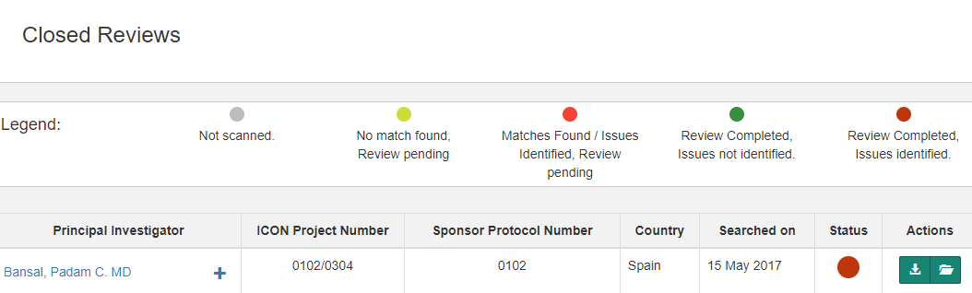

- Compliance form can be downloaded
- Open any compliance form to edit/modify

Manage Reassignments

All compliance forms, Review Pending/Review Completed, appear under this tab.

Below are the actions user can carry out in this section -

- Compliance form can be assigned to any user
- Compliance form can either be closed/opened for edit

Annexture

Output file generation - Institute Compliance issue (yes/no)
- ‘Institute Compliance Issue’ should be set by checking IssuesIdentified for InstituteWorldCheck site. Similar check should be carried out to add Compliance Issue for any site in the output file.

Test Foot Note

